Create a file “calculation.sh”. Write a shell script to print

1. your are logged in as which user
2. in which directory you are
3. and in which terminal you are working
4. total number of files and directories in current directory

Ans:

1. get access control list of file.

1. Give permission to read and write to user “user1” for file .

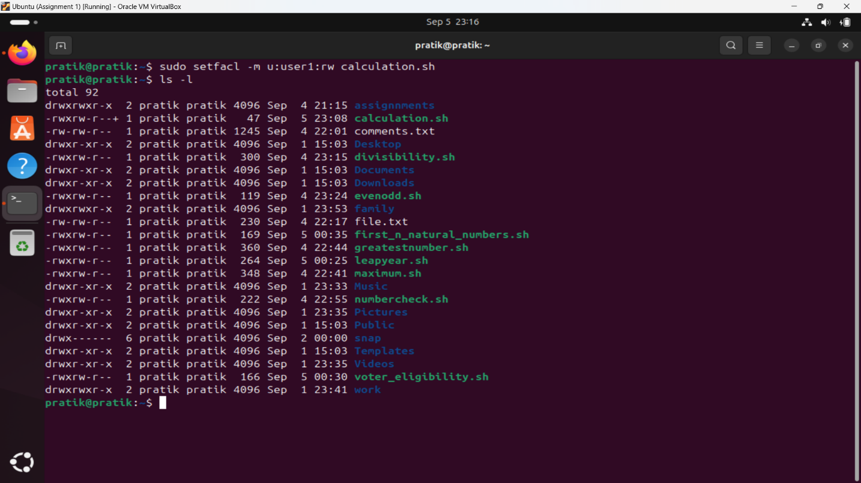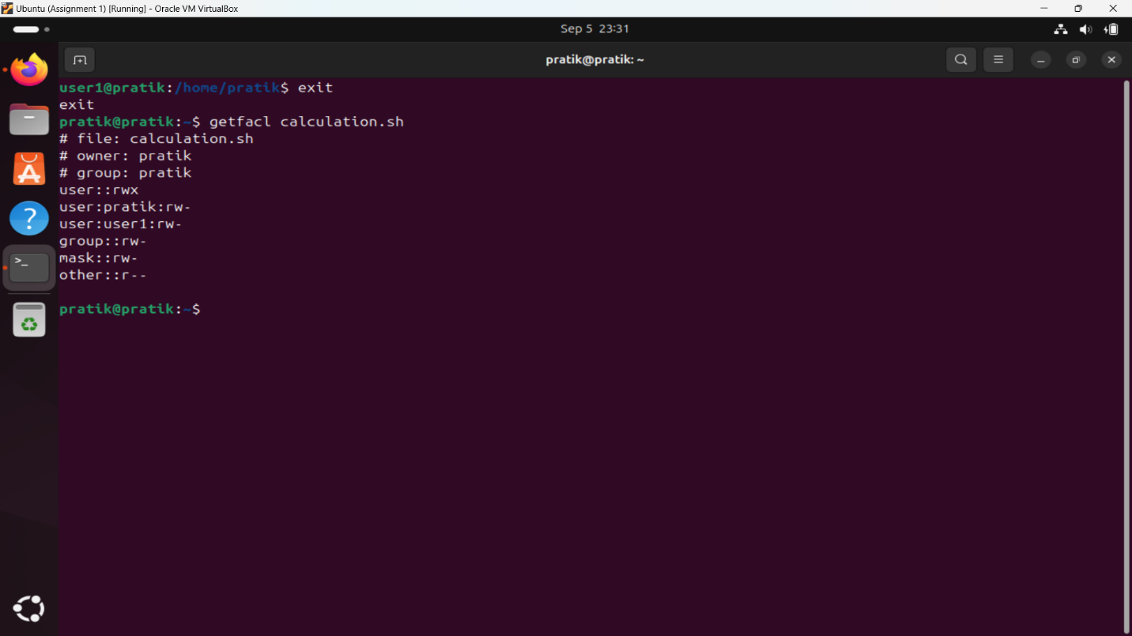

1. Give permission to read to group “dac” for file .

